**The NVivo practical**

Student’s Name

Professor’s Name

University Affiliation

Course Number and Name

Date of Submission

**The NVivo practical**

**Section 1: Qualitative Data Analysis**

The qualitative data analysis focuses on three key aspects related to climate reparations: attitudes toward climate reparations, the overall position of each article on climate reparations, and the contextual use of the term "colonialism." The analysis employs NVivo software to code and organize data from three news articles (A, B, and C) written by different authors and published at various times (Bazeley, 2013)

***Q1:Attitudes to Climate Reparations***

1. ***Figure 1:Sunburst***

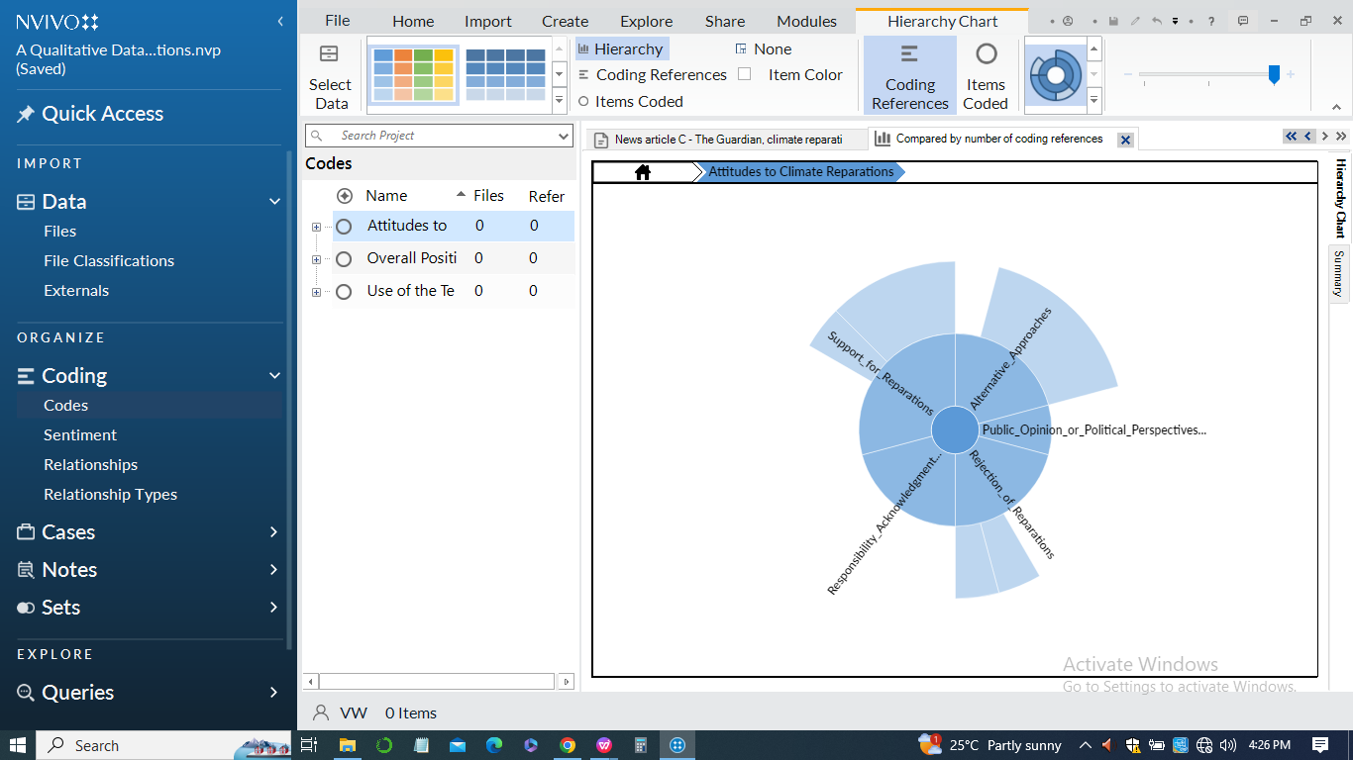

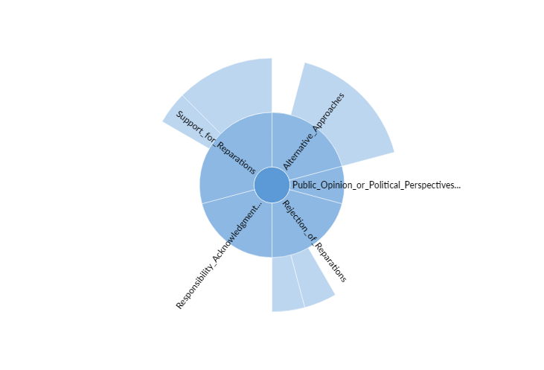

1. *Article A - Daily Mail*

Rishi Sunak opposes the idea of paying trillions in reparations, emphasizing the need for supporting developing countries in transitioning to a cleaner future.

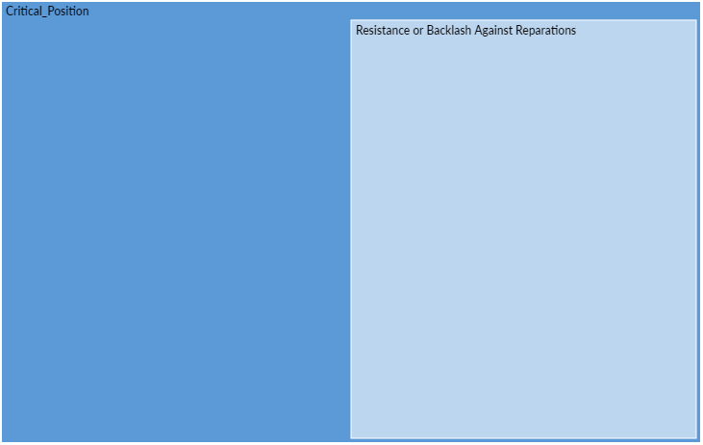

*Alternative Approaches*

1. Emphasis on Transition: Suggests utilizing UK funds to help developing nations transition to cleaner futures while benefiting British businesses.
2. Focus on 'Loss and Damage': Supports discussions on 'loss and damage' to address climate-fueled impacts without explicitly framing it as reparations.
3. *Article B - Euronews*

Discusses growing global calls for climate reparations, focusing on the vulnerability of Global South nations and the need for accountability from historically high emitters therefore presents a more positive attitude towards climate reparations.

*Alternative Approaches*

1. Distinguishing Finance and Reparations: Differentiates between climate finance and reparations, suggesting that finance can be seen as an investment or charity, while reparations imply liability.
2. *Article C - The Guardian*

Presents a study proposing significant climate reparations ($170tn) from wealthy, historically high-emitting countries to those needing to transition from fossil fuels thus Article C is supportive of climate reparations.

*Alternative Approaches*

1. Commons-Based Compensation: Introduces a compensation system based on the atmosphere as a commons, holding historically high-emitting countries liable to ensure equitable use.

***Q2: Overall positions of each article on climate reparations***

***Figure 2:Hierarchy chart***

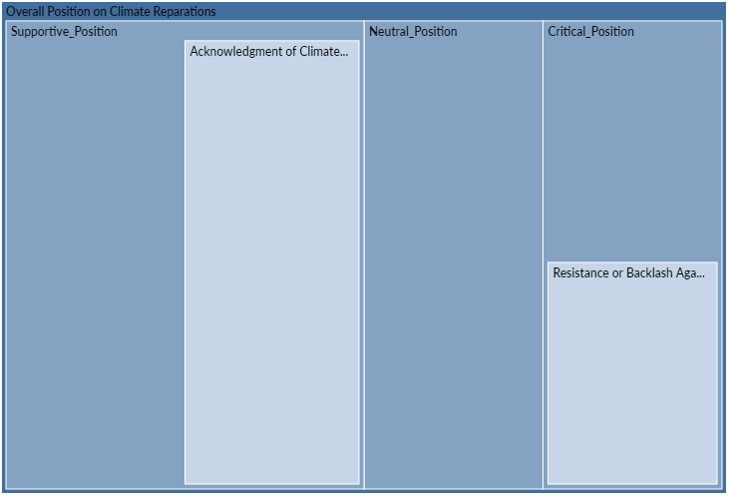

1. *Article A - Daily Mail(9th November 2022)*

Overall Stance: Strongly opposes the idea of climate reparations.

***Key Points***

1. Rejects the payment of trillions in reparations.
2. Emphasizes that such payments are "not the right approach."
3. Frames discussions on 'loss and damage' without explicitly considering it as reparations.
4. *Article B - Euronews(27th July 2022)*

Overall Stance: Supports the case for climate reparations, especially for countries in the Global South

***Key Points***

1. Highlights calls for reparations globally.
2. Frames the case for reparations as irrefutable.
3. Distinguishes between climate finance and reparations, emphasizing the need to recognize historical emissions.
4. *Article C - The Guardian(5th June 2023)*

Overall Stance: Proposes a compensation system based on historical emissions, holding wealthy countries liable.

***Key Points***

1. Presents a study calculating potential climate reparations.
2. Frames the compensation as a matter of climate justice.
3. Introduces a system based on the idea of the atmosphere as a commons.

***Q3: Context of the word “Colonialism”***

1. ***Figure 3: Comparison diagram***

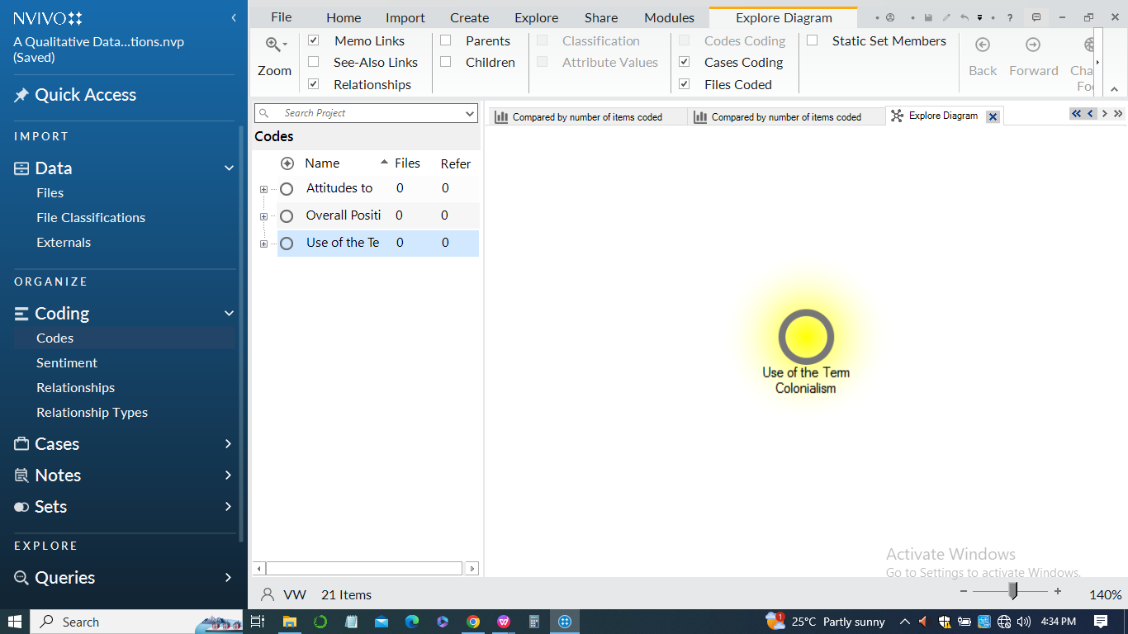

1. *Article A:*

The term "colonialism" is used in the context of discussing the idea that richer nations, including the UK, should acknowledge their role in climate change due to their historical industrialization. The article mentions that there are calls for richer nations to recognize their role in climate change, emphasizing that they industrialized their economies before other parts of the world.

1. *Article B:*

Article B explicitly links the climate emergency to a legacy of colonialism. It highlights that the climate crisis is considered a legacy of colonialism, and despite contributing the least to the crisis, people of color are disproportionately affected.

1. *Article C:*

In Article C, the term "colonialism" is not explicitly used. However, the article discusses the proposed climate reparations in the context of historical responsibility and the disproportionate impact on certain populations. It emphasizes the need for compensation to address the unfair burden placed on nations that are asked to rapidly decarbonize but have not been responsible for excess emissions.

**References**

Saldana, Johnny. 2015. Te Coding Manual for Qualitative Researchers. 3rd edition. Los Angeles; London: SAGE Publications Ltd. (Chapter 3 “First cycle coding methods”) Available as a hardcopy at the library

Bazeley, Patricia. 2013. Qualitative Data Analysis: Practical Strategies. London: SAGE (chapters 11-13; pp. 327-421). Available as a hardcopy at the library 3.

Charmaz, Kathy. 2006. Constructing Grounded Teory: A Practical Guide through Qualitative Analysis. SAGE Publications. Available as an e-book on the library website 15.

Boyatzis, Richard E. 1998. Transforming Qualitative Information: Tematic Analysis and Code Development. SAGE. 14.

Fereday, Jennifer & Eimear Muir-Cochrane. 2006. “Demonstrating Rigor Using Tematic Analysis: A Hybrid Approach of Inductive and Deductive Coding and Teme Development”, International Journal of Qualitative Methods 5(1): 80-92. 16.

Jack, Tulia. 2020. Qualitative Coding and Analysis using NVivo PC/MAC Workbook. Lund University. Download from Canvas 6.

Bazeley, Patricia. 2013. Qualitative Data Analysis: Practical Strategies. London: SAGE. (Chapter 6 “Naming, organising, and refining codes”) Available as a hardcopy at the library 13.

King, Gary, Robert O. Keohane, and Sidney Verba. 1994. “CHAPTER 1: Te Science in Social Science.” Pp. 3–33 in Designing Social Inquiry. Princeton University Press. Available as an e-book on the library website 7.

Glaser, Barney G., and Anselm L. Strauss. 1967. Te Discovery of Grounded Teory: Strategies for Qualitative Research. Chicago: Aldine Pub. Co. 17.

**Appendix Excerpts for NVivo Coding Analysis**

1. ***Figure 1: Sunburst***

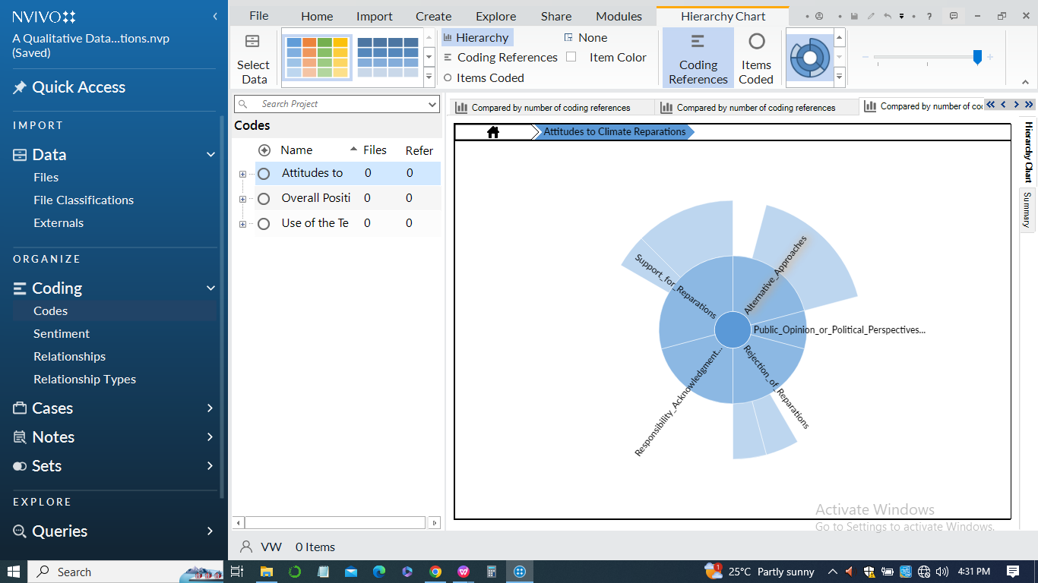

1. ***Figure 2:Hierarchy chart***

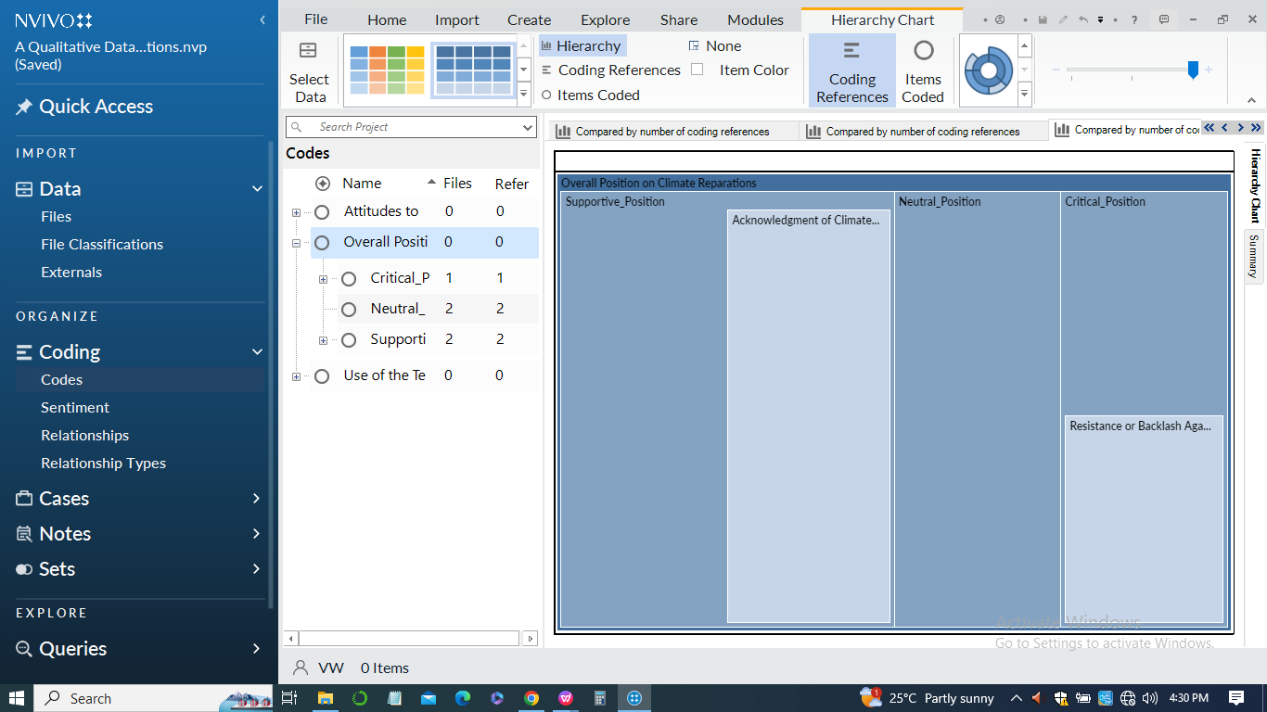

1. ***Figure 3: Comparison diagram***

